CMPE 273 LAB 1

Aniruddha A Narkhede

SJSU ID: 015451267

YouTube link: https://youtu.be/hiA501gnOug

Introduction:

Objective:

To develop a Prototype of Etsy application, a web-based application; frontend using React JS, backend using Node JS, and MySQL database for storing customer, shop owner and product details. The actors for the application will be:

• Customer

• Shop owner

MySQL database will be used to manage the data such as user profile, product details, order details, favorites, categories etc. for the entire web application.

Purpose:

Etsy application will provide below functionalities:

1. User –
   * User can view the featured or most popular products suggested by etsy without signing in or even after signing up.

* User can register and “Sign in” (Redux implementation code).
* User can update the profile details like profile picture, basic personal information like name, date of birth, city, email address, phone number, full address (mandatory), country with dropdown.
* After sign in user can view the options like logo, search bar, favorites tab, profile, shopping cart etc.
* User can search the products to buy based on product name.
* User can sort by price, recently viewed browsing history, filter by price, color, category or sales count.
* User can add or remove the products from the cart or in the favorites list and should be redirected to shopping product overview page.
* User can place the order after reviewing cart.
* User would be able to view order history.

1. Seller –

* Seller’s shop name should be unique, and he can check the availability in the “Sell” tab.
* Seller can register and sign in the products with Etsy stating shop name, images, owner details, list of all the products along with the product counts he wish to sell.
* Seller can update the profile along with the list of products he wishes to sell.
* Seller can add, update or remove one or more product details like name of the product, images, product category, description, price, quantity available.
* Seller can add payment details or account information in which he would receive the purchase amounts.
* Seller can buy the products listed in the web application by any other seller (can act as user).
* Seller can receive the orders and can update status of the orders.

1. Profile Page –

* With user profile page, user can update and view the information like first name, last name, email, phone number, address, photos, country with dropdown and about yourself etc.
* With seller profile page, seller can update and view the information like first name, last name, email, phone number, address, photos, country with dropdown and about yourself etc.

1. Product details –

* User can view the featured products or most popular products after visiting the webpage before login or after login as well.
* User can browse through multiple products by searching the products on web page “search” functionality.
* Products can be sorted or filtered based on price, category, color and sales count etc.
* After clicking through the product user can see the product image, product description, shop name (hyperlink to shop homepage), sales count, price, select quantity option, add to cart or add to favorite button.
* User can add the product to cart or favorite list based on choice.
* User gets the message as “Out of stock” if the sales count is 0 for product.

1. Favorites Tab –

* User can add the products into the favorite tab by clicking on the “Add to favorite” button.
* Favorite tab will have the list of the products liked and added by each user in their personal account.
* User can remove the products from the favorites tab if already bought or lost interest.

1. Place the Order –

* User can add or remove the product from the cart.
* User can specify the quantity of the products he wishes to purchase.
* After selecting the product user wishes to purchase, he can update the payment information, delivery address and finally click on “Place the order” to finalize the sell.

1. Shopping cart Tab –
   * User can view the products he wishes to purchase based on quantity he needs.
   * User can update the quantity or remove the entire product if not interested.
   * User can buy all the products listed in the cart after reviewing the list.
   * User can remove the products from the cart and add it to favorites if he wishes to purchase in later stage.
   * User can view the product image, name, price and quantity of the product.
   * User can add products from multiple shops, it is not limited to each seller.
   * User would be redirected to “My purchases” or “Order history” page once he places the order.
   * User can see the order id generated after each successful order placed.
2. Edit Products –
   * Seller can add, update or remove the product from etsy on their shop home page with the details like name of the product, images, category, description, price and quantity available.
   * Products can be categorized based on Clothing, Jewelry, Entertainment, Home Decor, Art or in case if there is a new category, seller can add the new category.
   * User gets the “Out of stock” error if he wishes to purchase the quantity of items more than the available options or in case of 0 availability.
3. Orders Tab –
   * Users and sellers can view their respective orders page.
   * Sellers can see the orders places by users along with the user and payment details.
   * Seller can update of an order like “Order Received”, “Shipping”, “Shipped”, “Delivered” etc. for the deliver products options.
   * Users can pick up the products if seller has provided the “Pick up” product option.

System Design:

The Etsy application allows the users to search for a particular product based on category or shop name. User can browse through multiple products and select the once he is interested in by adding them either or cart or favorites list. On the seller side, it allows the seller to add, update or remove the product from their shop as well as receive order requests from the users and update the status of these orders.

The stack used for developing this application is as follows:

1. Server side –

NodeJS and Express

1. Backend database –

MySQL

1. User Interface and Front-end Development –

ReactJS

- By making API calls to the server using NodeJS, backend MySQL interacts with the front end ReactJS in the system.

- NodeJS receives the response data by querying the database to get the response once ReactJS makes the requests to the backend MySQL data.

- ReactJS send the requests to insert or update the data into the MySQL by sending details to NodeJS.

- Redux and Cookies functionality is used to manage the user or seller sessions.

- Various ways are used to perform data validations and exceptional error handling for each functions called or used in ReactJS.

Steps:

1. GET, POST API calls are made by ReactJS to get the desired output from backend.
2. NodeJS gets the requests from the ReactJS front-end and then it executes the database queries to fetch data, insert or update data.
3. After NodeJS requests MySQL performs CRUD operations.
4. Backend MySQL sends the requested response data to the ReactJS front-end and then it displays the data on the web page.

Results:

Application Landing Page:



Sign Up Page:

User

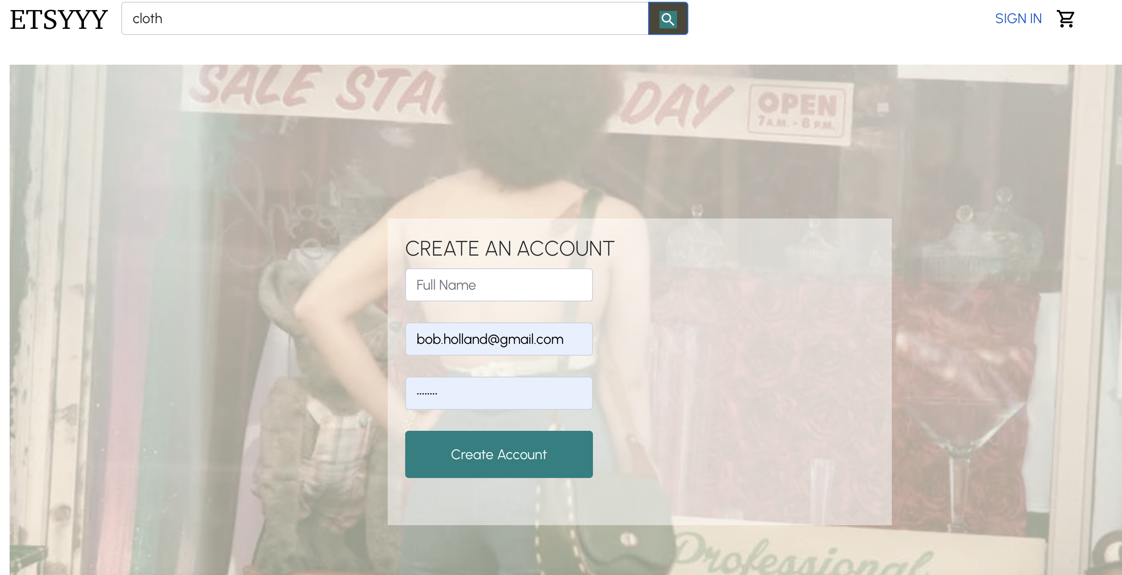

SIGN IN

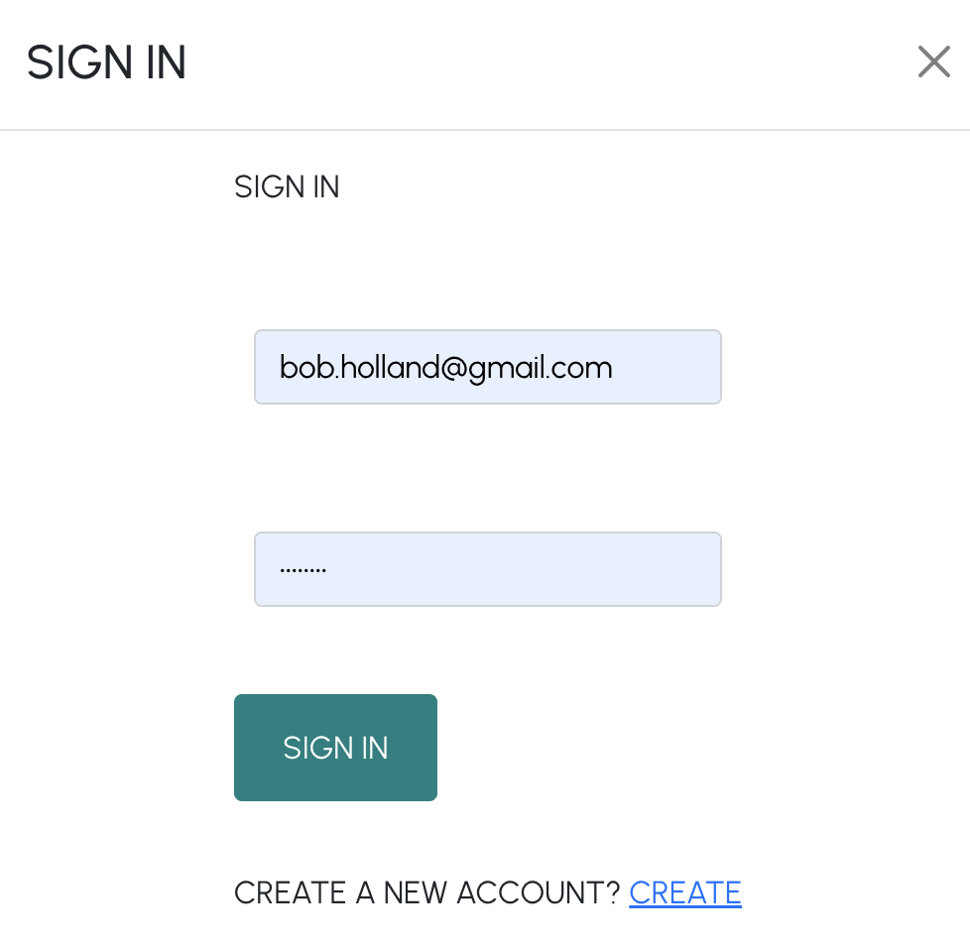

User logged in:



Users favorite page:

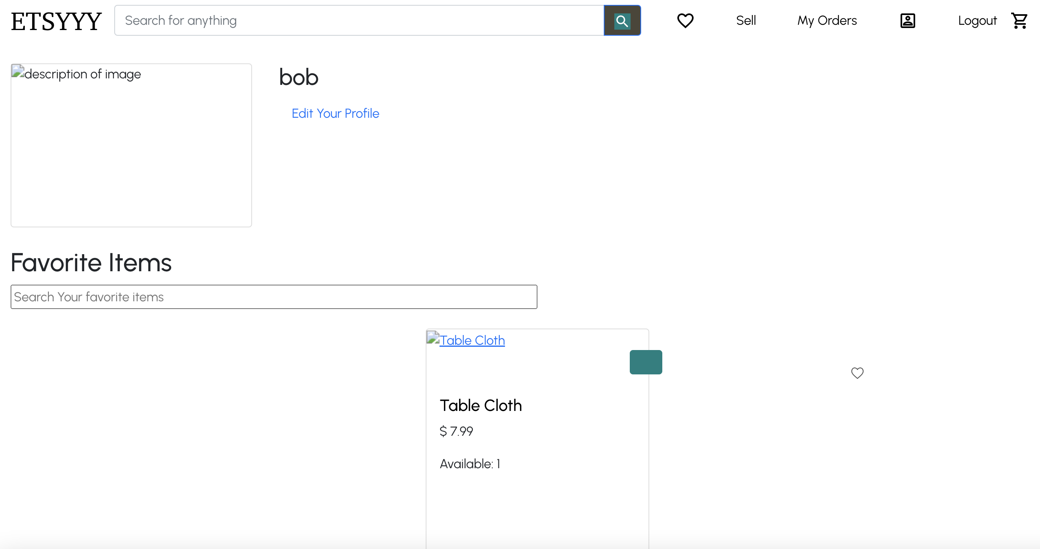

Shop page:

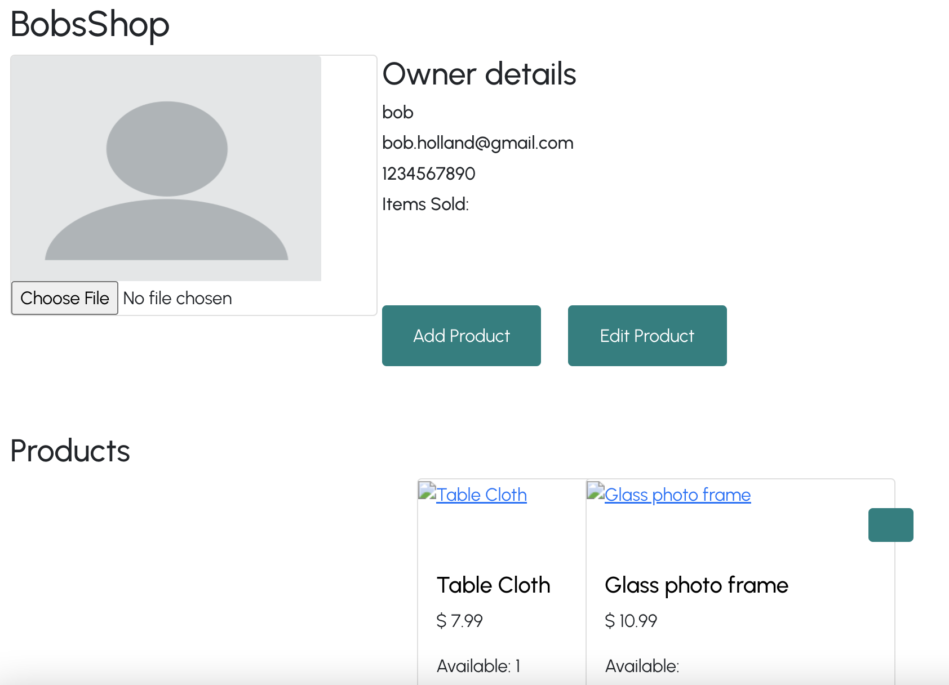

Add product page:

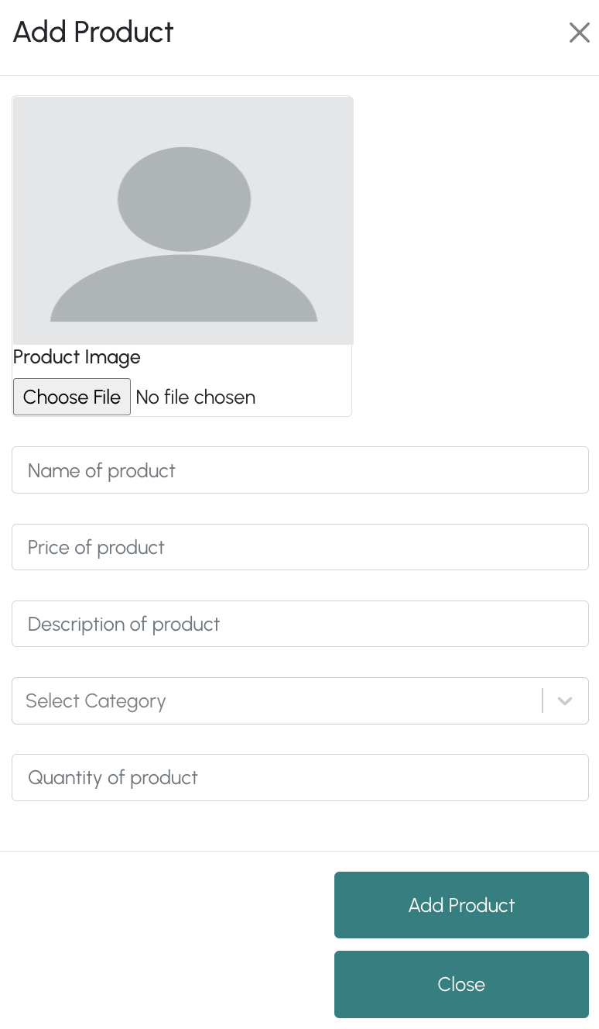

Edit produce:

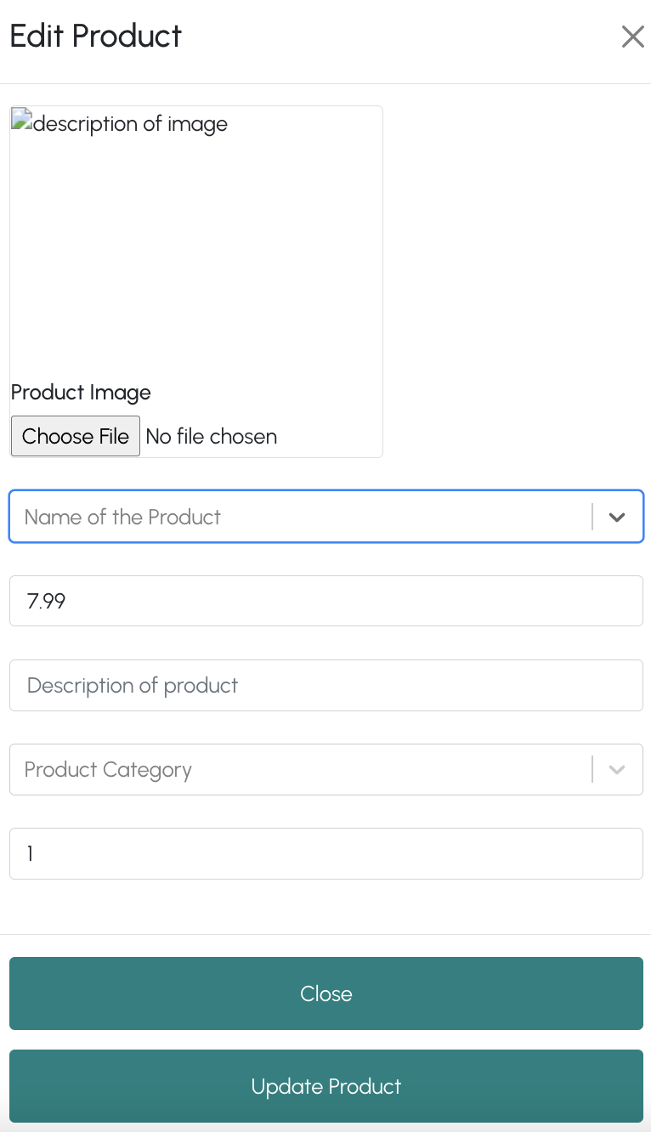

Profile:

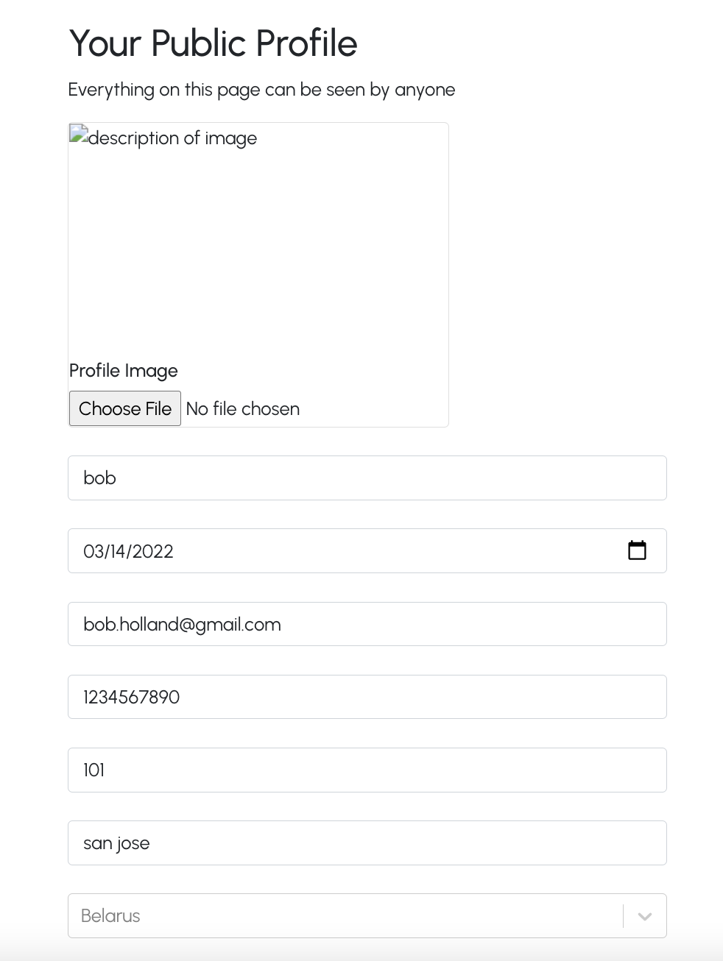

Purchases:

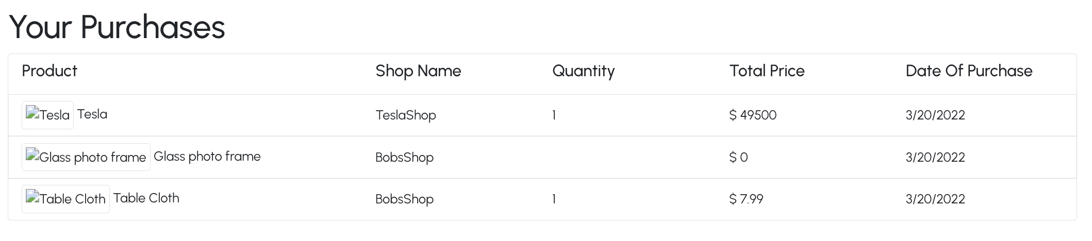

Cart:

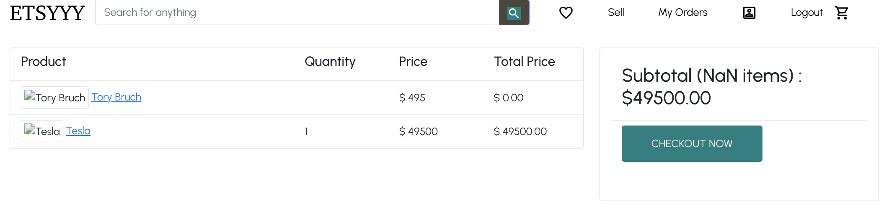

Search:

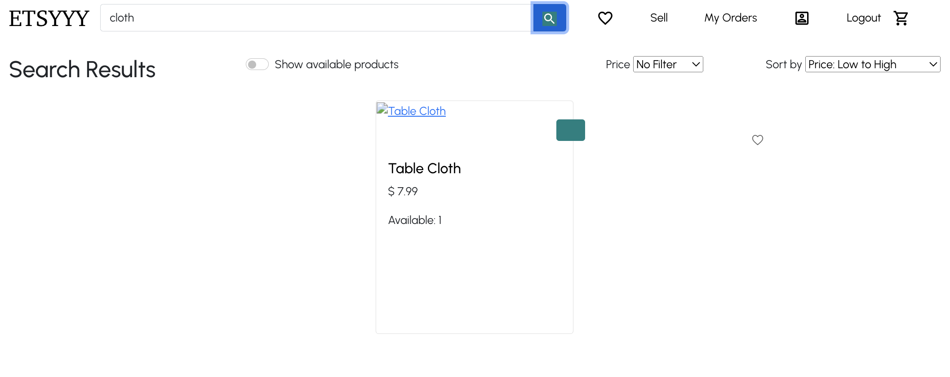

API Testing:

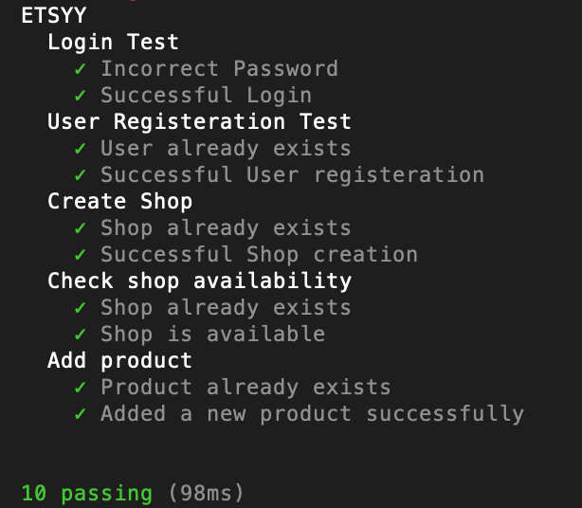

JMeter Performance Testing:

* + Without pooling

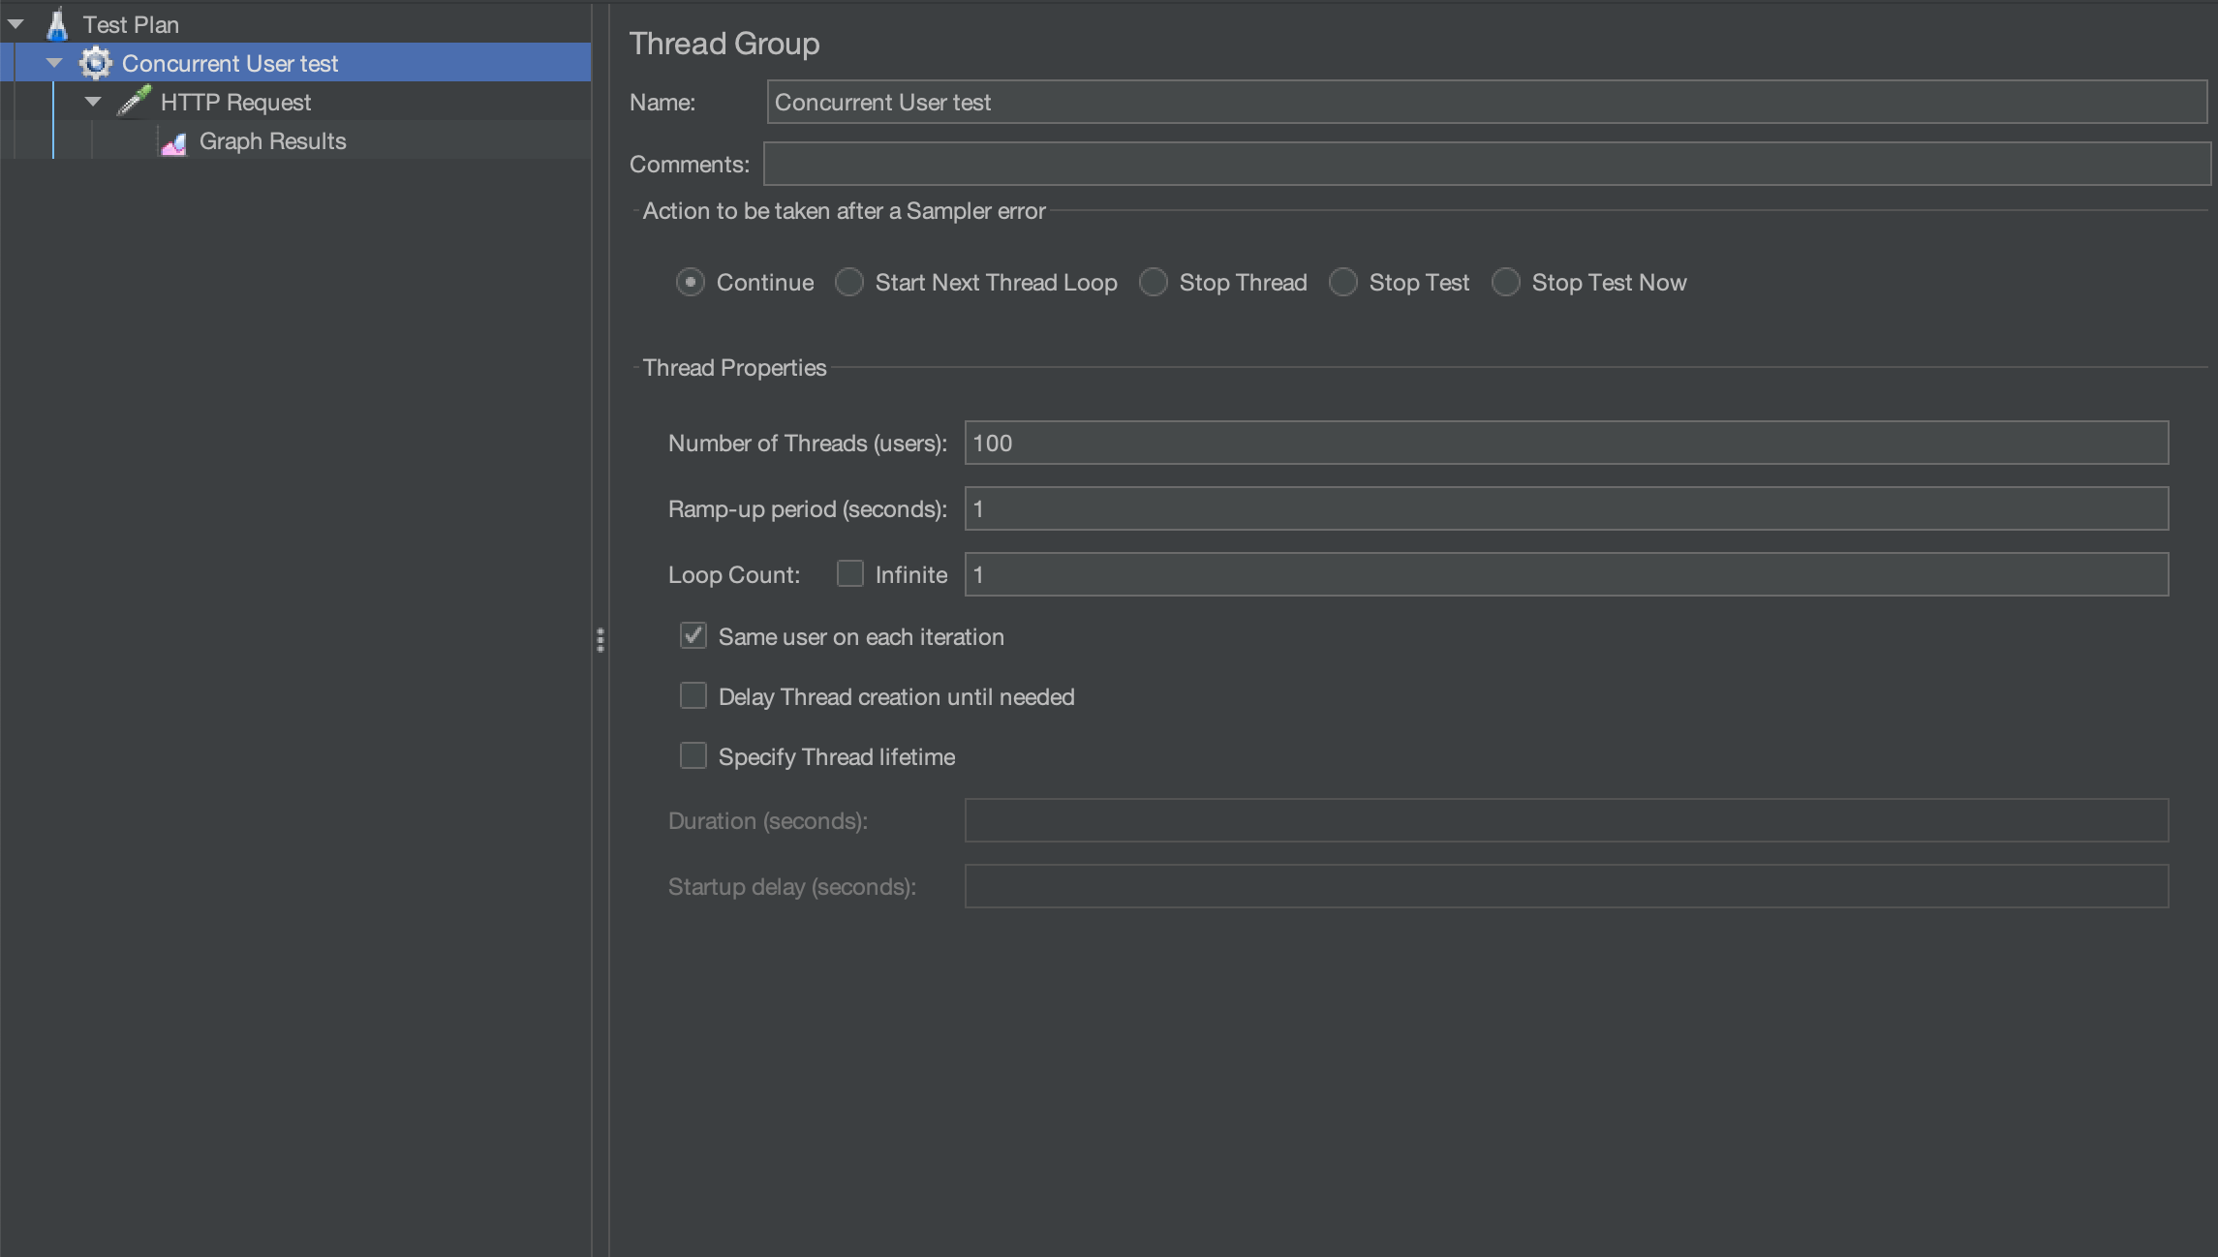

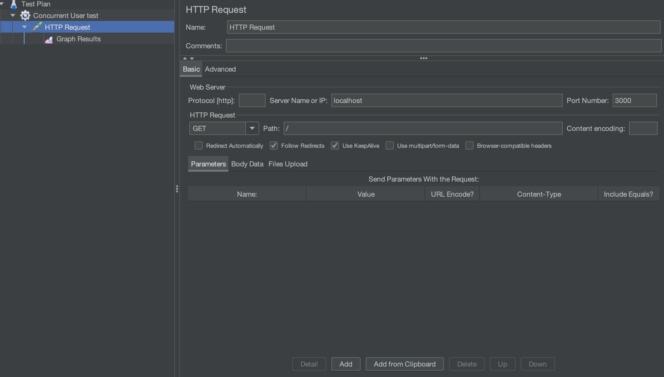

100:

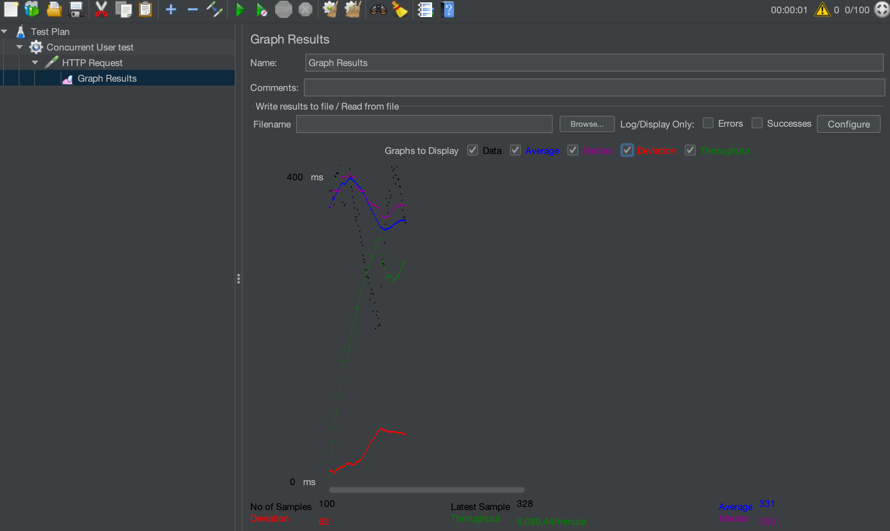

200:

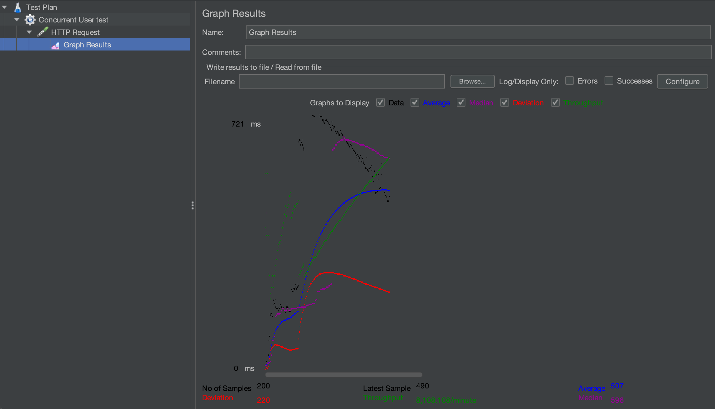

300:

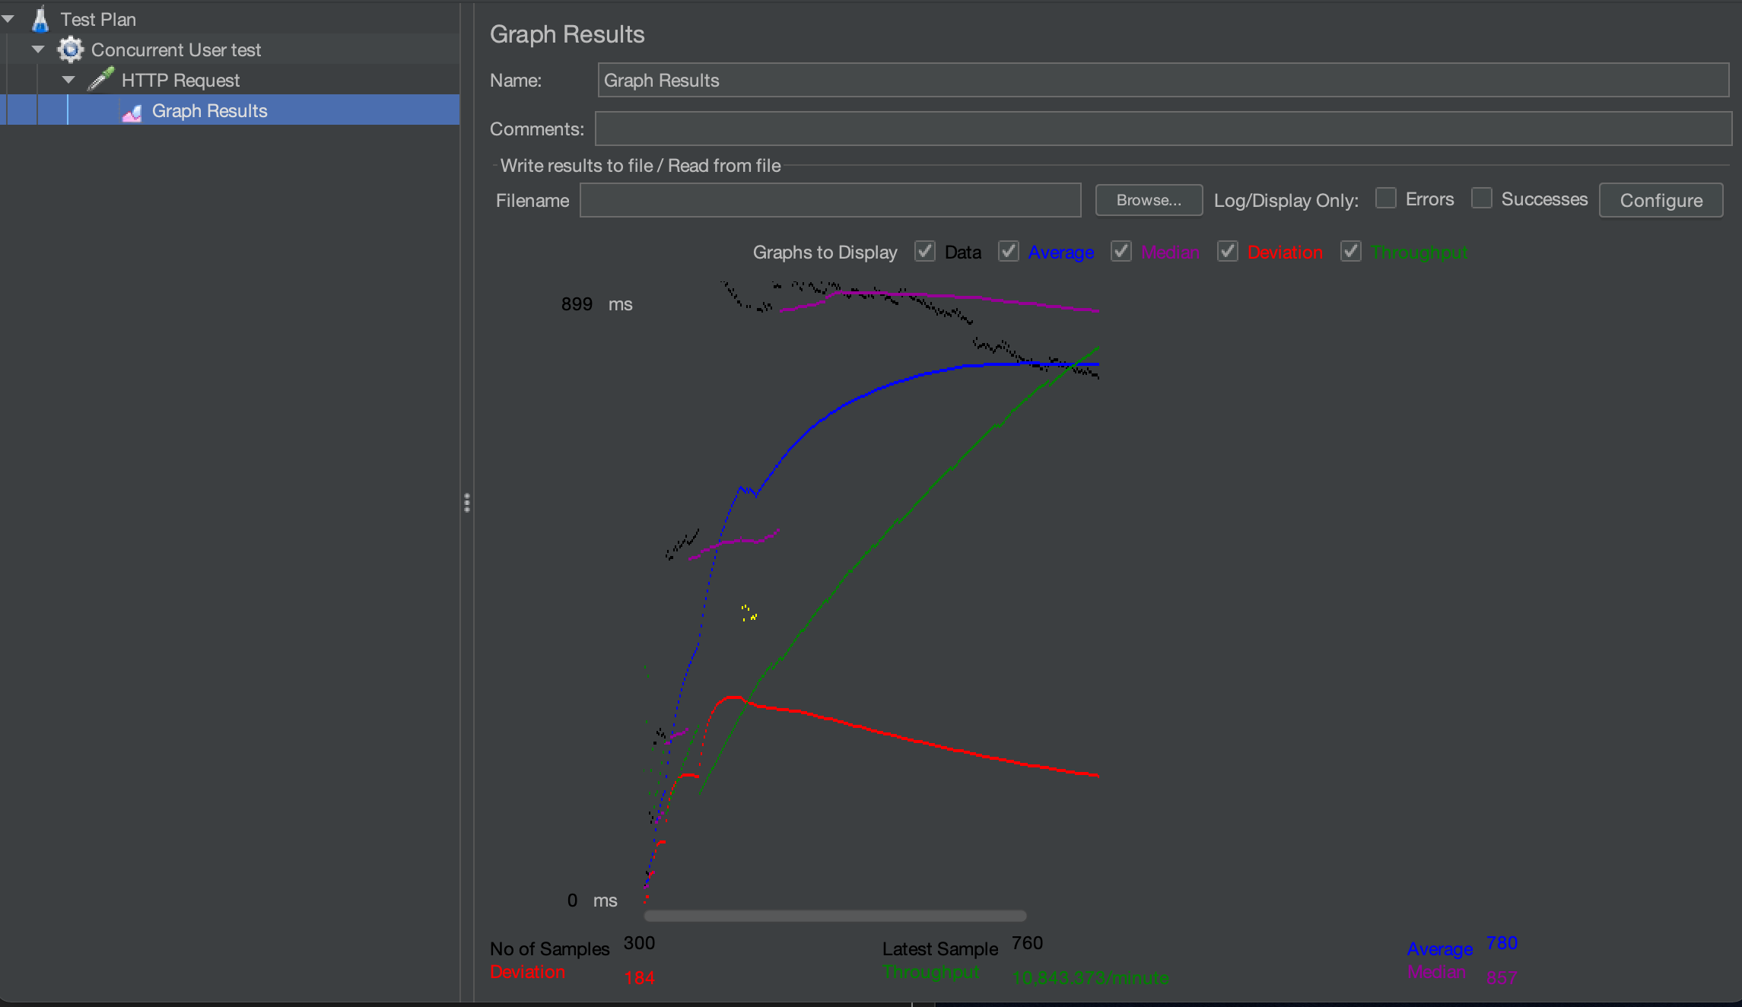

400:

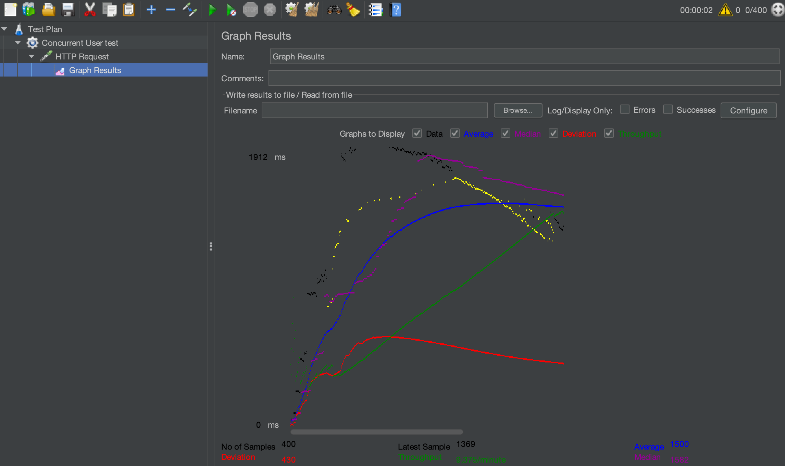

500:

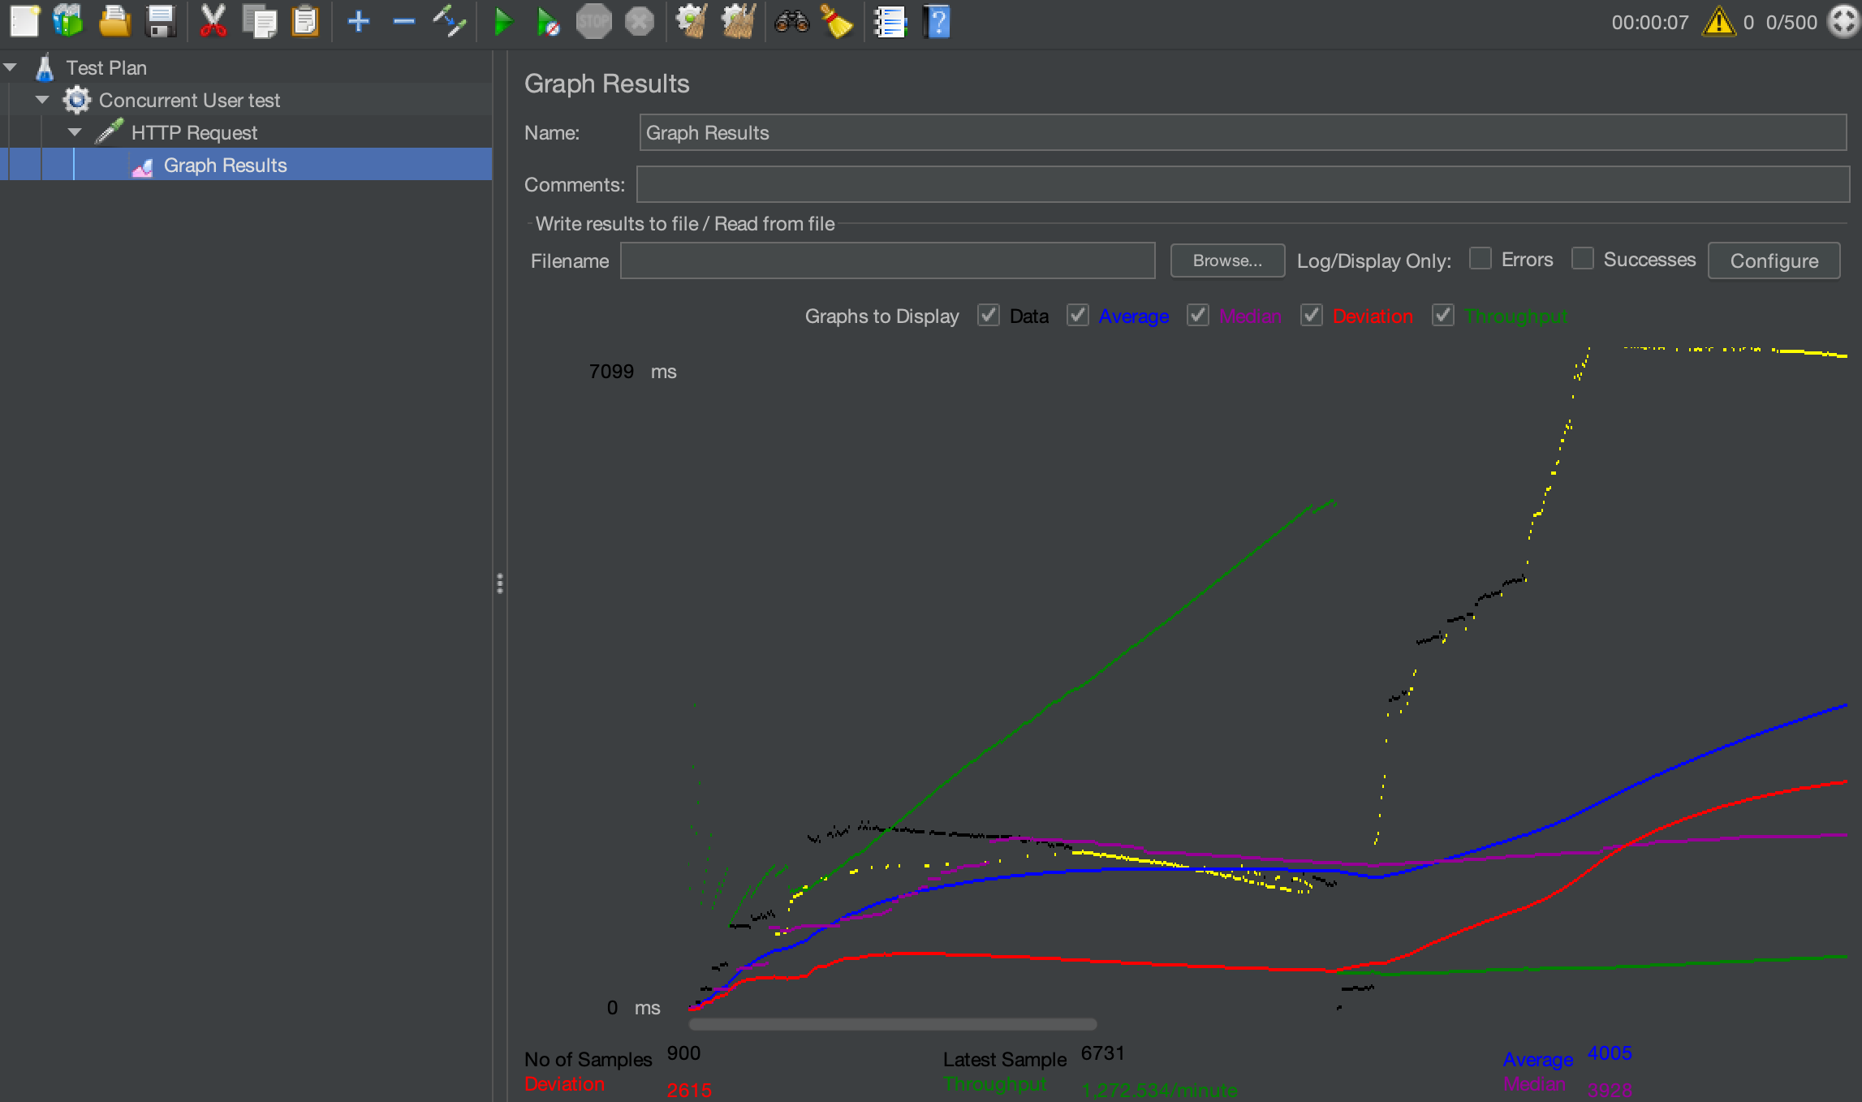

* + With Pooling:

100:

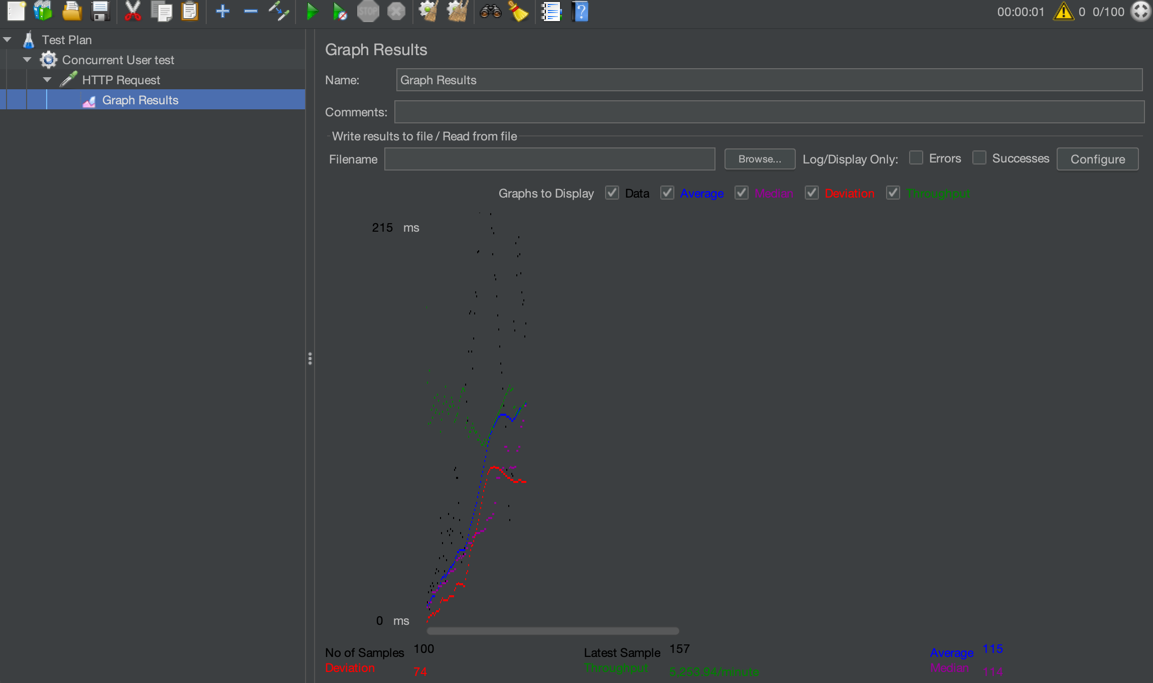

200:

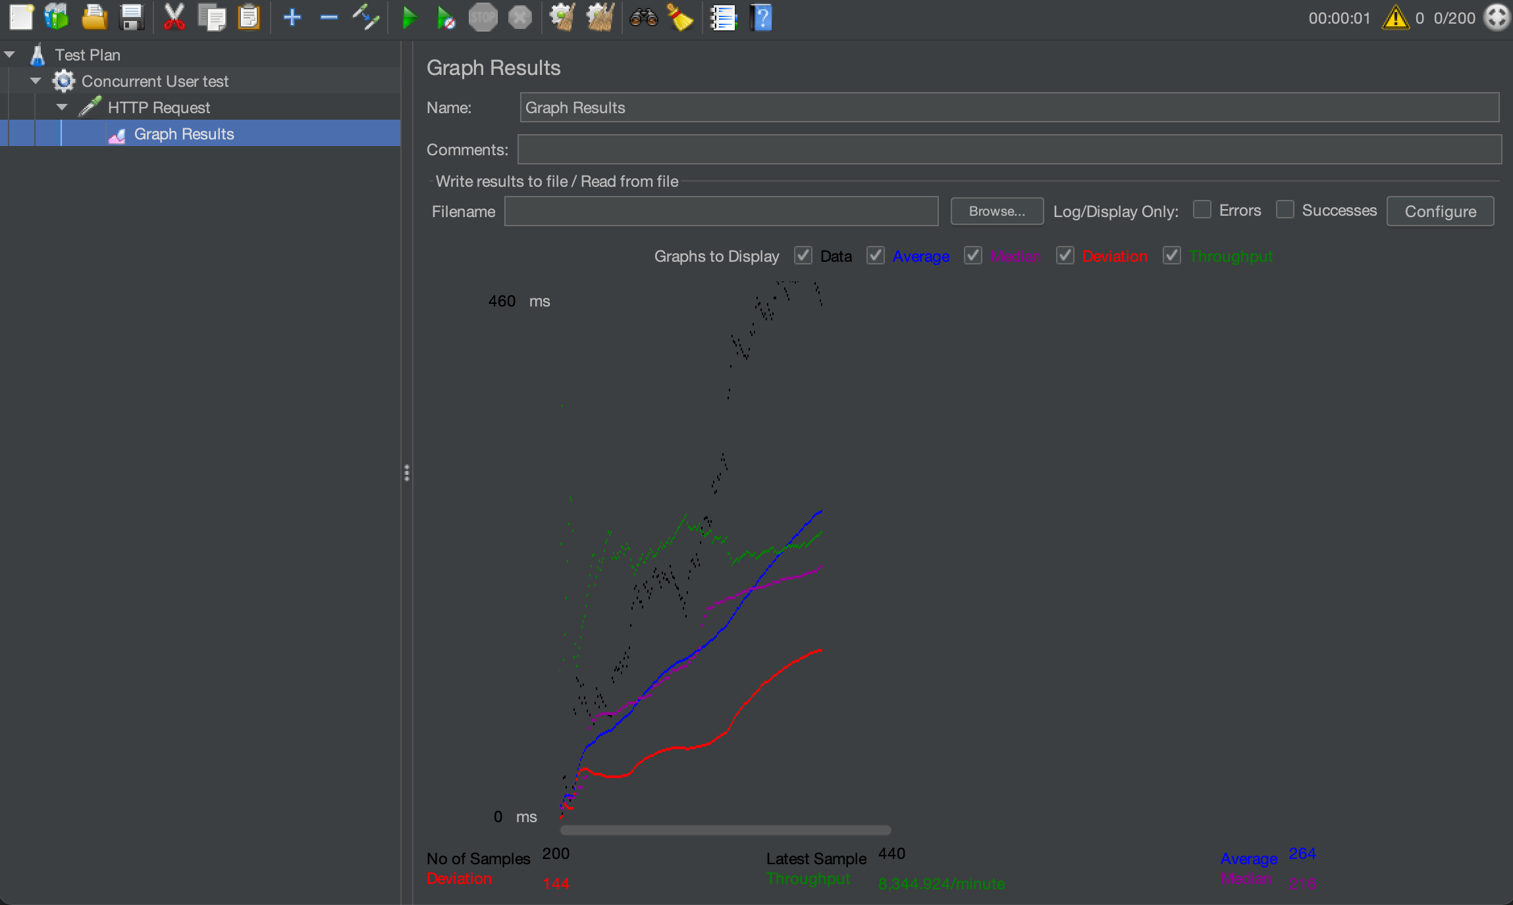

300:

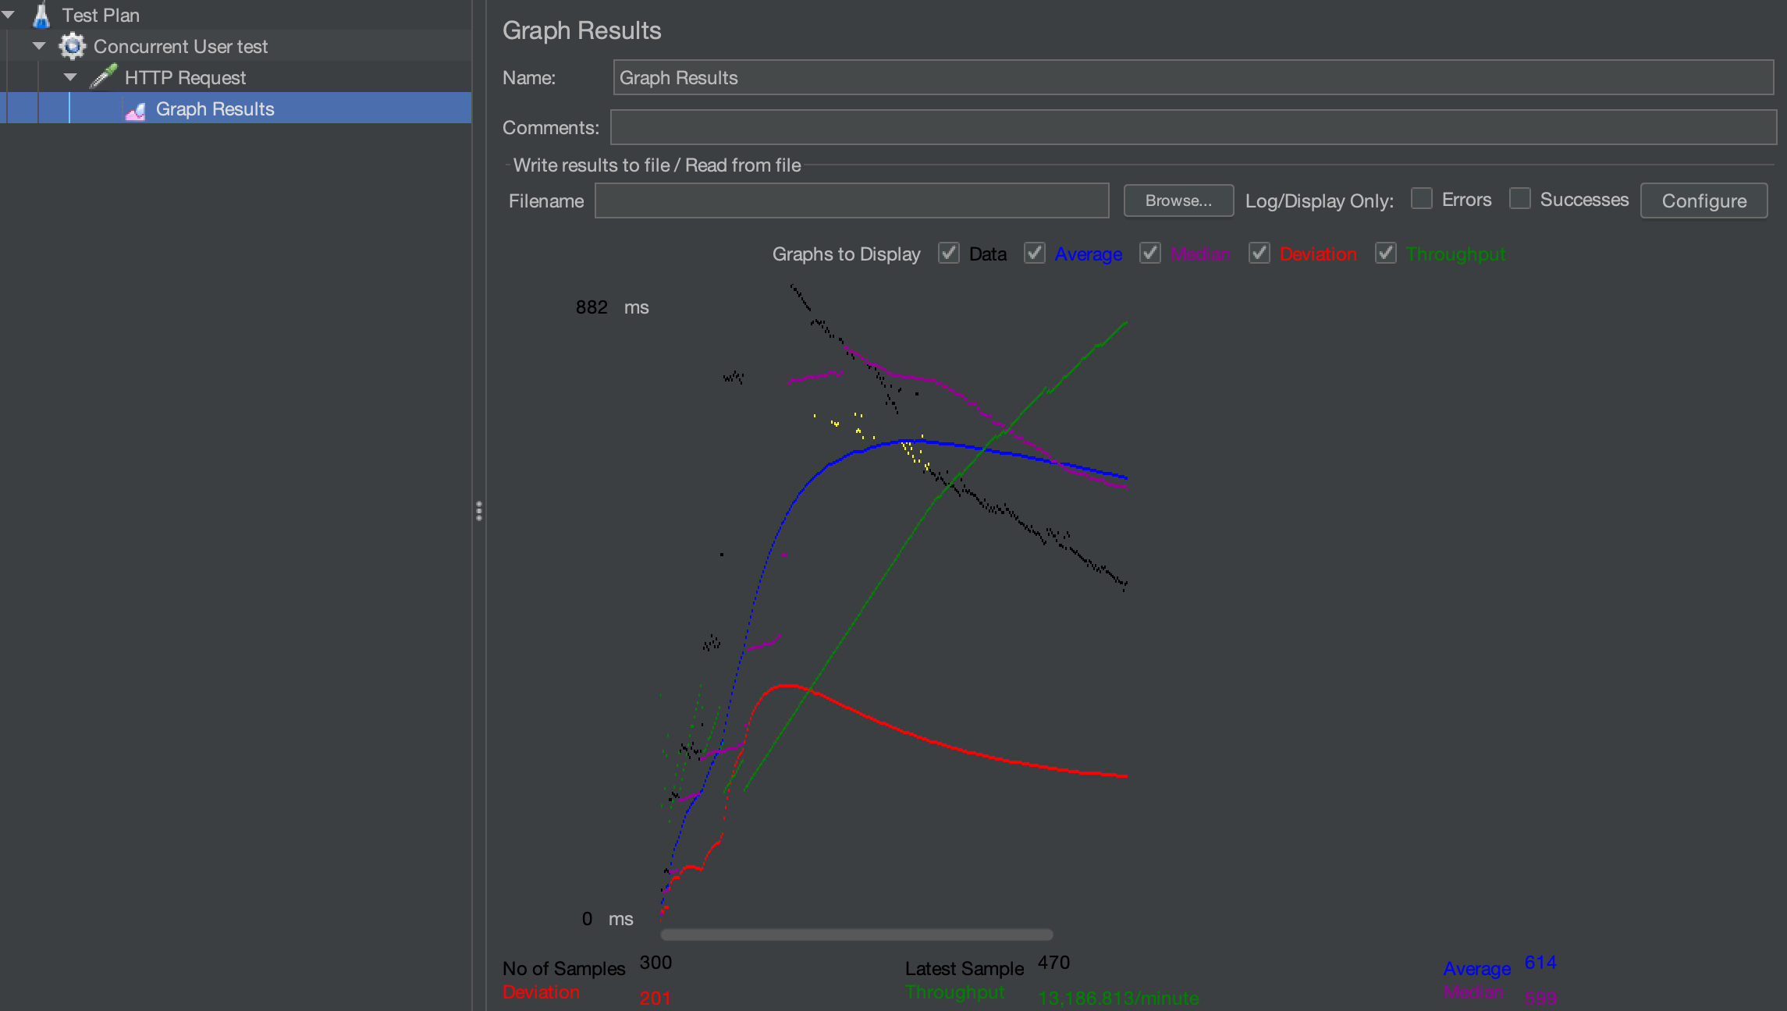

400:

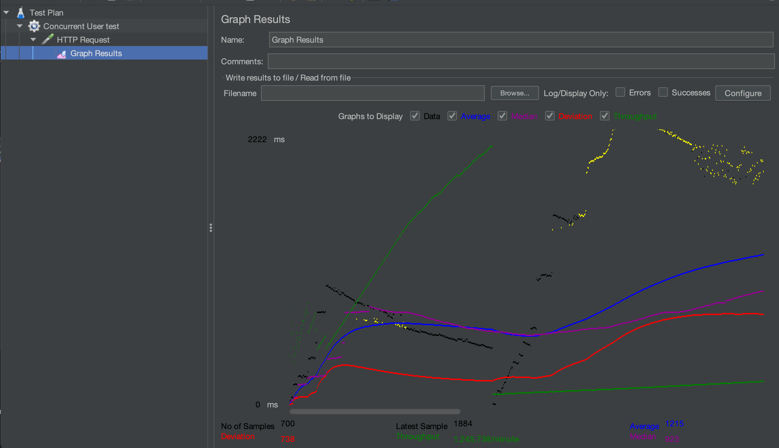

500:

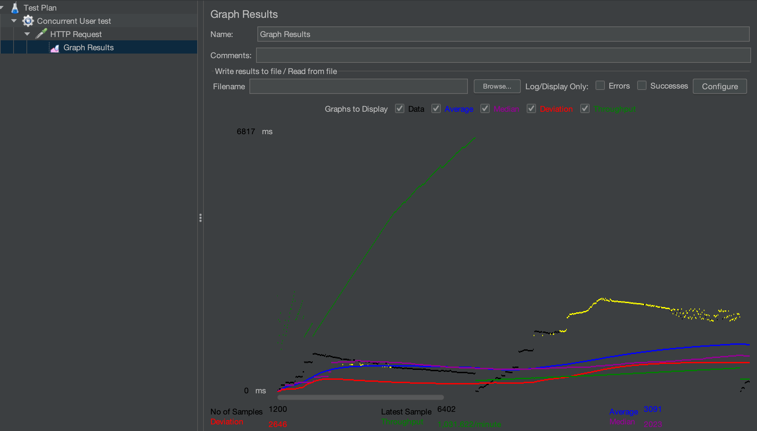

GIT commit history:

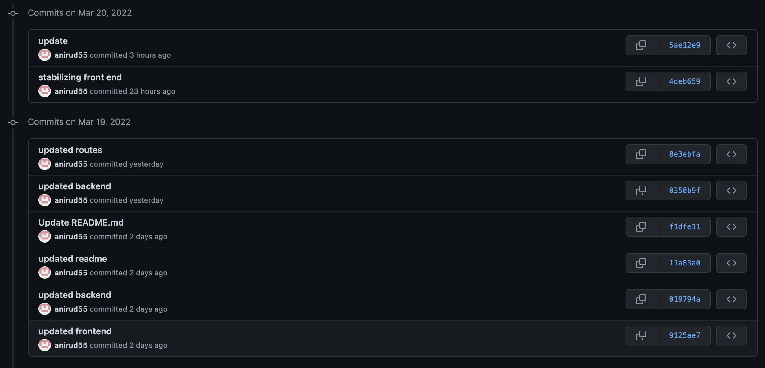

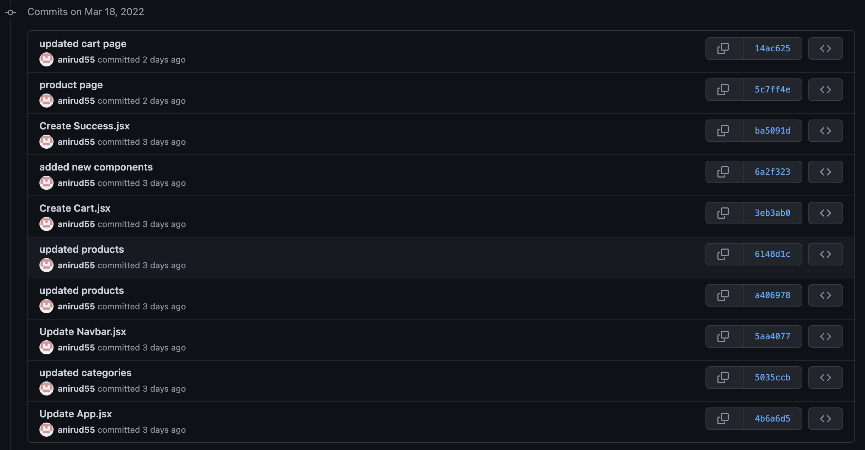

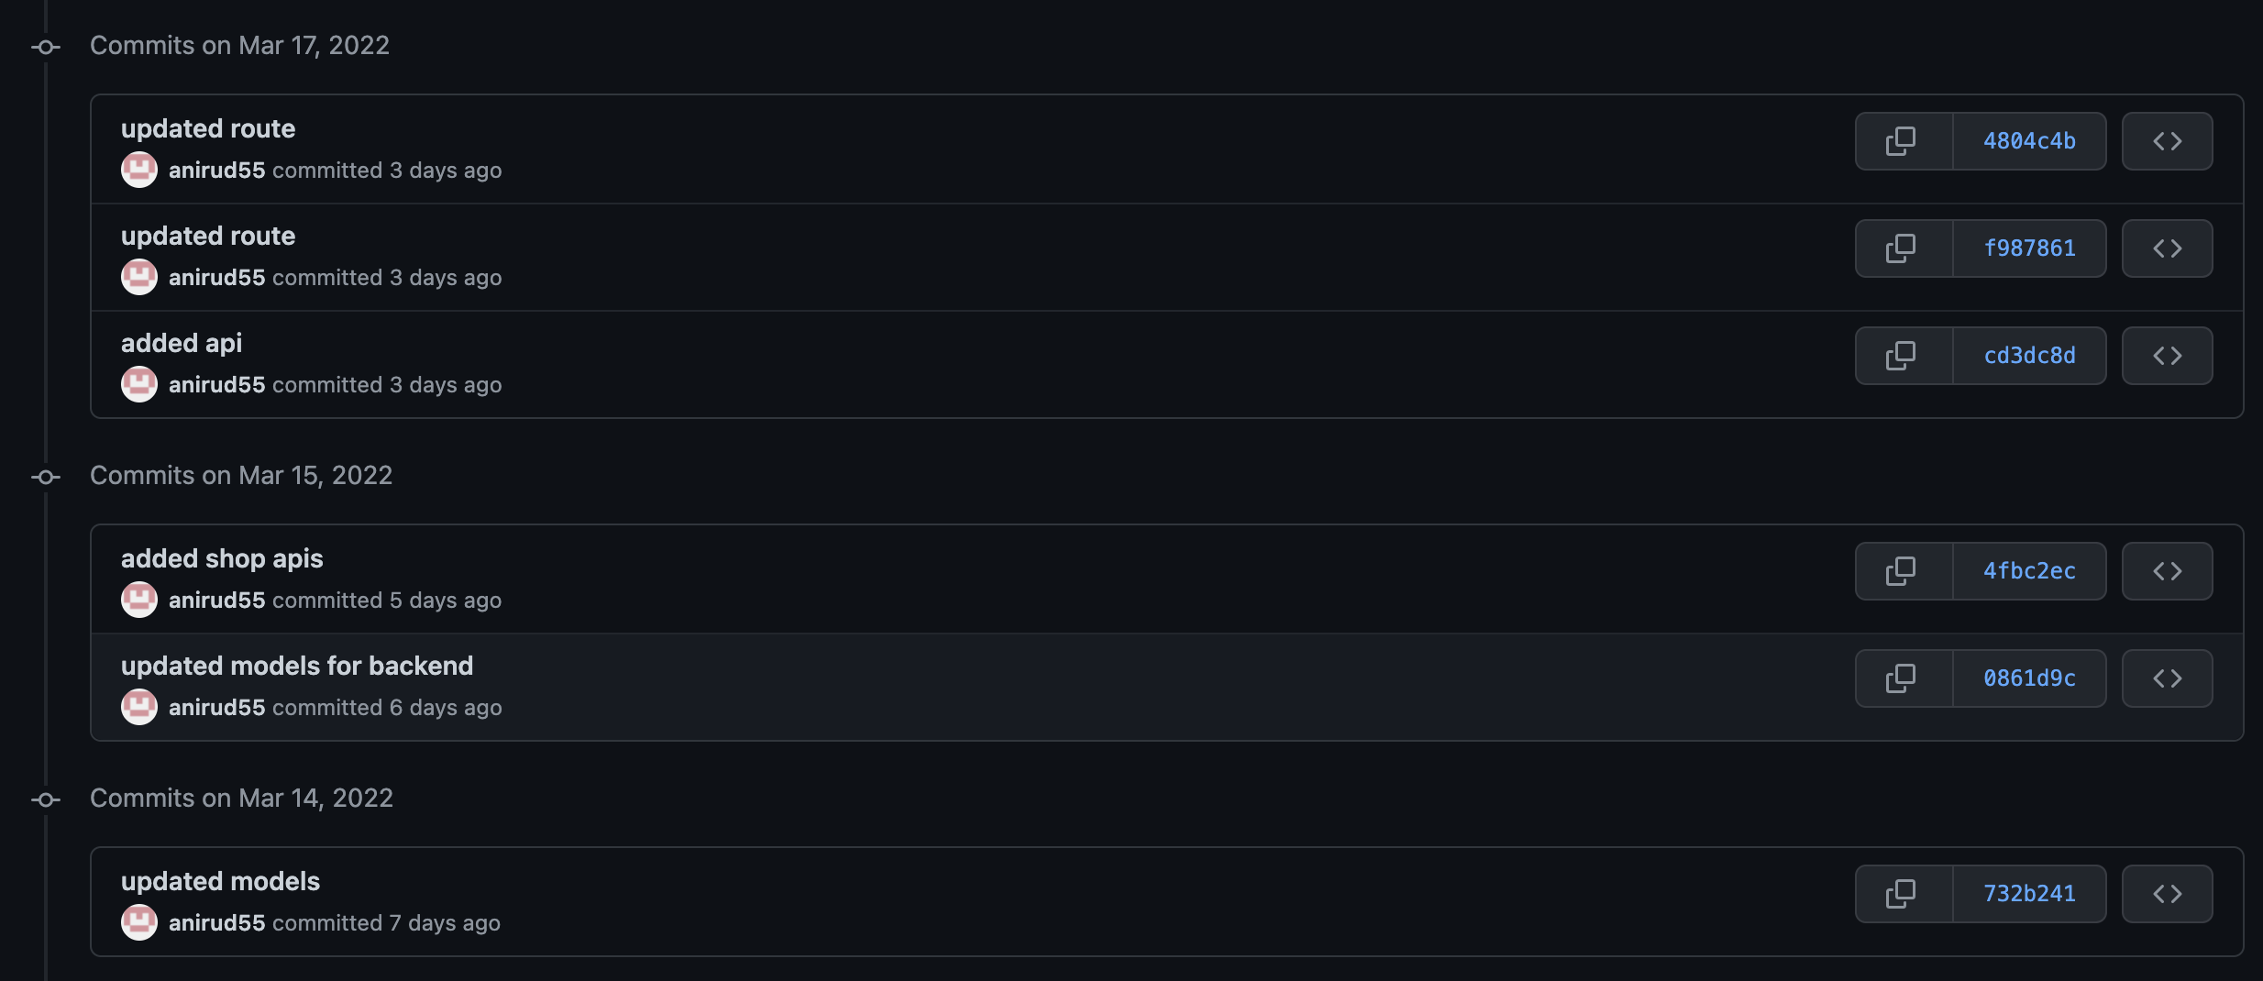

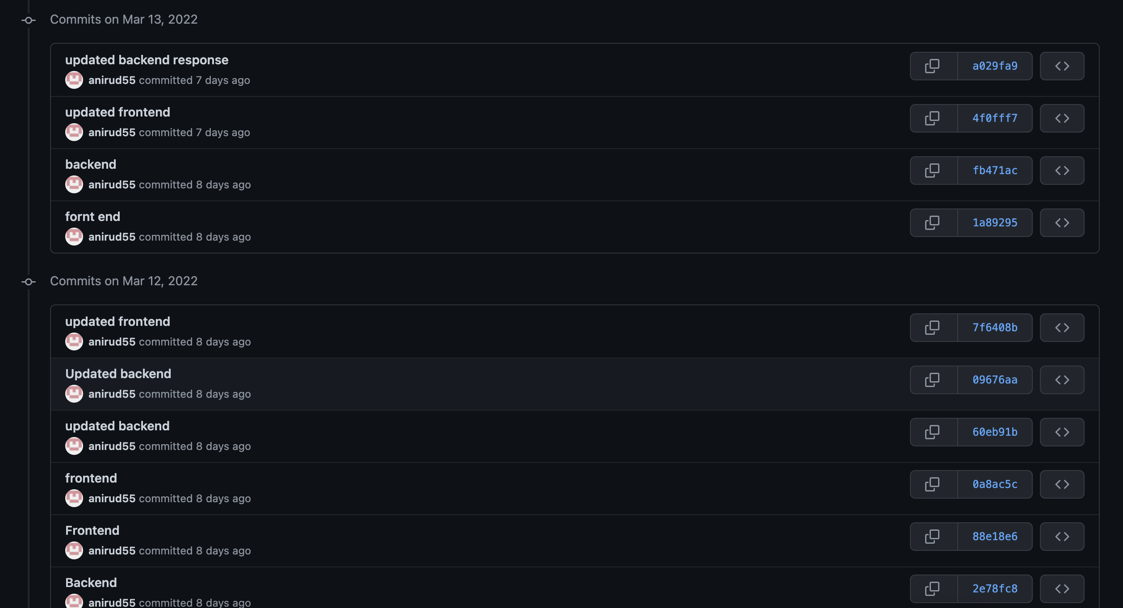

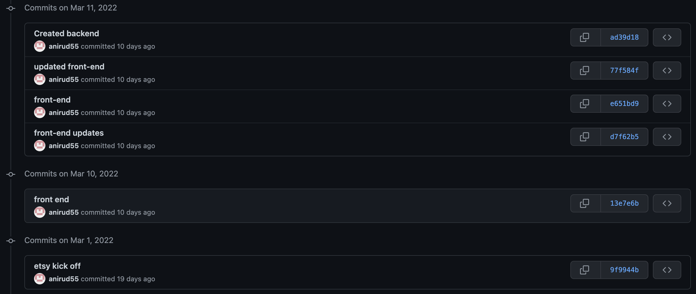

Lab Questions:

1. Compare the results of graphs with and without in-built MySQL connection pooling of the database. Explain the result in detail and describe the connection pooling algorithm if you need to implement connection pooling on your own.

Use of CreatePool will help in pooling the connection with the database.

Backend pooling for database MySQL in my Etsy retail web page is implemented as follows:

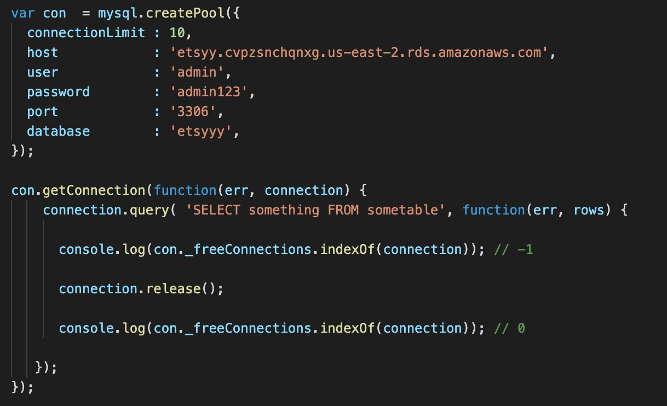

Connection pooling is the concept which helps in improving the efficiency of executing multiple queries at the same time by defining the strategy to reduce the cost of opening and closing the multiple connections to the back-end database.

Traditionally if not using connection pooling, multiple threads are created for each request made to the database. Connection pooling avoids this multiple thread creation for each request and creates a single pool of request that executes each request one after the other. So, for multiple requests coming in for the backend, it creates the queue of requests and requests are served based on priorities. This in turn results in the reduction of database calls each time.

If connection pooling is not used, the performance of the app is reduced as database latency increases that ultimately results in increased overall response time for the website, this can be avoided using connection pooling.

Connection Pooling Algorithm:

* + 1. Creates a stack of connections
    2. Once requested, pop the connection from the stack
    3. If the connection is given back, push it back to the stack (which in turn helps in caching the connection details)
    4. Clear the pool in case of specific associated connections is closed or timed out

Connection Pooling Graph results:

* 1. Without connection pooling, the results for concurrent users are linear which represents the neutral query execution performance.
  2. With connection pooling, this query execution performance is faster as application doesn’t need to create connection for each request.

1. What are the ways to improve SQL Performance? List at least 3 strategies. Explain why those strategies improve the performance.

Various ways to improve the SQL performance are as follows:

* + - 1. Create Index on columns based on cardinality –

Create the index on the few columns in the table based on the column cardinality. For example, if high cardinality, create the b-tree index on the column. Index cardinality is the concept which represents number of distinct unique values in the column.

Using the indexed column in where condition or on join condition, helps in retrieving the query results faster as it would not scan the whole table to retrieve few records.

* + - 1. Avoid SELECT \* use SELECT [column] instead –

Select \* would fetch all the columns in the table while dealing with the big datasets which in the end is unwanted data.

For few scenarios, we would just need specific columns instead of the redundant information. To avoid this specifying the exact column names being queried is useful.

* + - 1. Avoid sub-queries and using JOINS

Sub queries and joins gives performance issues in case of big datasets resulting in delayed response time for the user.

Sub-query first executes the inner query and then gives the results to outer query, then outer query gets executed using the inner sub-queries result which in turn slows the overall process of responding to the server.

Join works in similar way where 2 queries need to run parallel and then combine the results based on join column, which again affects the query response time.